2nd Iteration of ENTIRE EDIH Skills Development Program “AI Fundamentals – Constraint Based Scheduling”
Helmut Simonis

Summary
We ran the second iteration of the scheduling program on Feb 17/18, the program was attended by eight participants. Three additional registrations were no-show or cancelled the day before the course was started. The majority of this iteration of the course were from research (university/centres), in contrast to the first iteration in November 24 when most participants were from industry. The feedback questionnaire was only available for this last run.
The course can be considered a success, with participants being happy about the content and the presentation. For a largely research oriented audience, more in-depth explanations and a more hands-on approach might be considered in the future. Given the time constraints, this would require a significant reduction in the topics covered, or a longer course. An academic one-week school on scheduling could be easily created from the course materials.
Working with the scheduling tools in a practical session should be considered with this type of audience, we did not do this as the effort required to install the tool on machines of the participants was considered too large, while we do not have in-house infra-structure to provide pupils with ENTIRE owned machines. Using CSIT labs was considered, but was considered too disruptive to the flow of the course.
The course contents fits nicely into a two day in-person program, but this duration might create a barrier to entry for potential customers, especially from SMEs. It is not clear how to resolve this, a potential series of video lectures based on the course material might be an alternative. A two-day online event does not seem to be a practical alternative.

Detailed Analysis
Overall, the course was appreciated by the participants.
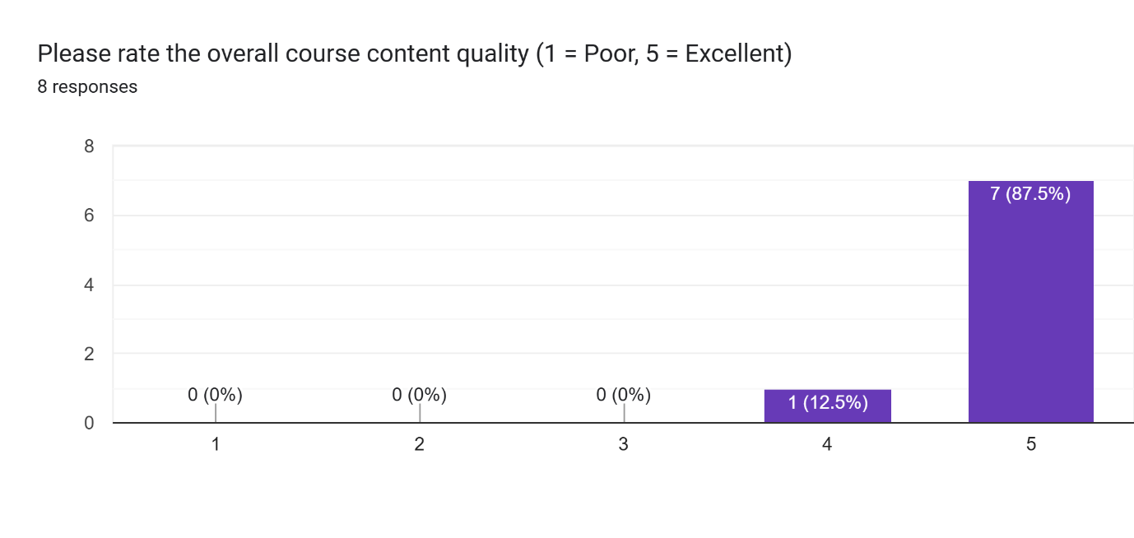
The slide set used for the course was valued
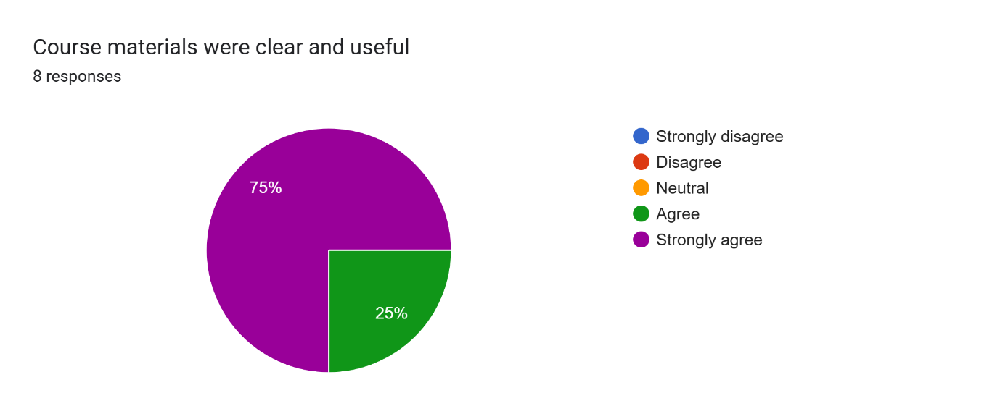

More detailed feedback was provided by the participants on positive aspects of the course:
What worked well in this course? (8 responses)
- Timely delivery of valuable content.
- Realworld use cases, KPI relation to objective functions and Quality vectors to evaluate solutions
- understand and take an idea about the scheduling in industry
- Prof Helmut's engaging and effective content delivery and his enjoyable presentation style made concepts more accessible, keeping the learning process both informative and stimulating. His vast experience with industry added significant value, as he provided real-world insights and practical applications of constraint programming in production scheduling.
- The presentation
- Background/context of area and problem was well explained and the material was very thorough
- Practical industry examples
- Course material was clear and delivered at a steady pace to allow nonexperts to keep up.
- Course leader was experienced on topic & provided helpful real world examples.
When asked, what could be improved, some more varied feedback was given:
- A little reduction in density of the slides
- I do not know
- I can understand more the nature of scheduling problem in industry
- Given the course's strict time schedule, Prof. Helmut has carefully curated the most important and engaging content to ensure an effective learning experience. That said, the course could benefit from additional technical content and experience on AI design and training specially for researchers.
- All was good
- There should be practical sessions of using the tools for scheduling. This course was 100% theoratical.
- Mathematics related and models architecture behind the scenes
- Suggest the Networking opportunity to engage both academic & industry experts is important at these events. Need to get a hook for industry to attend & collaborate.
When asked for additional comments, we received just a few comments:
- The question was explained well, and the solution was explained step by step. it was great.
- Very good course, with a great presentation
- The challenge of academic concepts (some with limited practical use ) versus industry goals (specific industry scheduling improvement) was clearly & carefully outlined. In fairness- Care was taken that gaps were addressed to keep both topics on track eg Visualization ideas.

